Evaluate and Communicate Business Requirements

Wells International Collage

Atsuyo Taniguchi 18296

|  |  |  |  |
| --- | --- | --- | --- |
| Name of Student | Atsuyo Taniguchi | ID | 18296 |

**Assessment – Research and Questioning**

Contents

Instructions: 2

Business Scenario 3

Task 1: Determine support areas 5

Task 2: Identify stakeholders 7

Task 3: Develop support procedures 8

Task 4: Assign Support Personnel 11

Task 5: Short Answer Questions 12

Task 6: Multiple Choice Questions 15

Search Index 27

**View my web support:**

**URL**

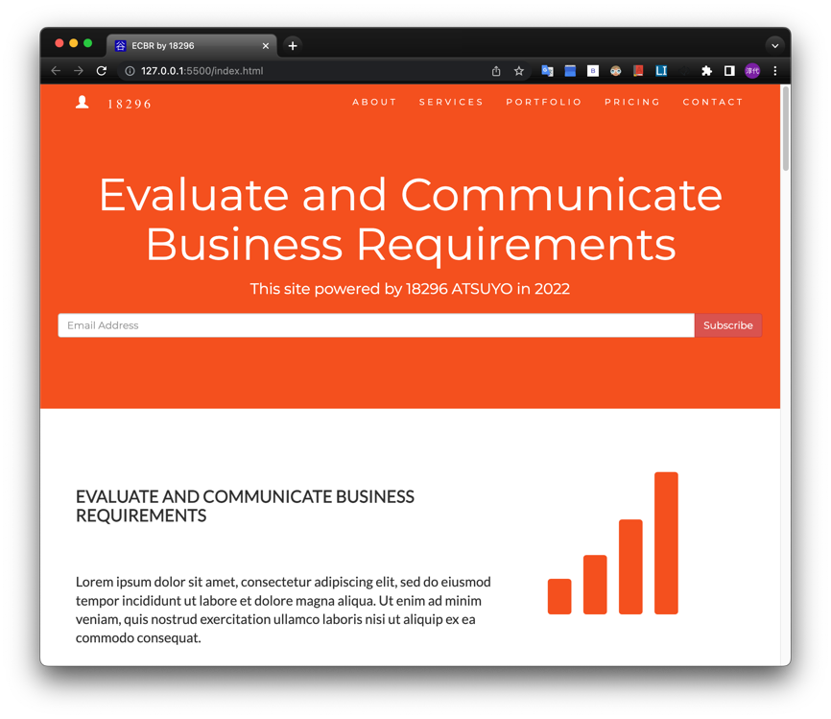

# Instructions:

This assessment is to be completed individually. In this assessment you will be working through a number of written tasks based on case scenarios or research that relate directly to each element of competency for this cluster. Outlined below is information on how each of the tasks relates the element of competency covered.

Learn how to make Google Form: <https://www.youtube.com/watch?v=BtoOHhA3aPQ&t=4s>

Your tasks:

# Business Scenario

D&K Books Pty Ltd is a bookstore owned by Mr. Dean Kerr. The business occupies two levels of an office building connected by escalators and lifts. D&K Books employs approximately six sales staff, one operation manager, two administrative officers, a bookkeeper and a marketing manager. They have an Ethernet network consisting of ten PCs (Intel I3 Desktop cloned), two switches, a router and three printers. They use the QuickBooks software to manage their entire business, including sales, inventory, ordering, accounts receivable, accounts payable, payroll and employee management. They also have two EFTPOS terminals one on each floor.

D&K Books has a Linux server that stores all of the data including the QuickBooks database. The server is backed up to tape regularly. They also have a website (hosted on an Australian ISP’s server, dynamic and static pages using asp.net) on which customers can browse the product catalogue and view current specials. They also lease a telephone system from Live Telecoms. The PABX (phone system) consists of a main switchboard and five remote phones with three incoming lines and a message-on-hold queue system.

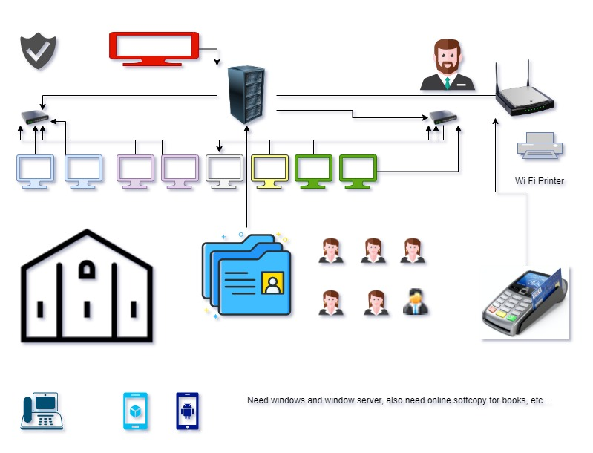

Good network system, you need setup at least:

|  |  |
| --- | --- |
| Hardware | Software |
| Server X 1 | Window Server |
| Computer X 8 | Windows |
| Printer X 1 | SQL server |
| Telephone X 8 | Virus Protection |
| Modern X 2 | MS office |
| Network Cable | EFTPOS machine, etc… |

# Task 1: Determine support areas

Identify information technology (HW and SW) and list the technology in use in D&K Books and consider the following:

* What sort of support does the technology require?
* Who is likely to provide this support?
* Does the support arrangement already exist?

Present your answer in a table such as the one below:

|  |  |  |  |  |
| --- | --- | --- | --- | --- |
| **Technology** | **Description** | **Support Required** | **Provider** | **Support Already exists? (Yes/No)** |
| **QuickBooks Software** | Software that manages their entire business | Customisation, training, upgrades, bug fixes (patching), user support | [QuickBooks](http://www.intuit.com.au/) | No |
| **PC’s** | Intel I3 Desktop cloned | Upgrades, repairs, troubleshooting, maintenance, backup, customisation, network to link | - | No  Need to find support |
| **Server** | Linux Server  Regular tape backup  May need to upgrade to hard disk or cloud backup | User account management, security policy implementation, home folder management, permissions management, backup and restore, operating system patching, software installation | [Linux Server](https://www.linuxserver.io/) | No |
| **EFTPOS** | Easy to use | No need | [EFTPOS Australia](https://www.eftposaustralia.com.au/) | Yes |
| **Telephone system** | PABX consists of a main switchboard, five remote phones with three incoming lines, a message-on-hold queue system | Leased | [Live Telecom](http://www.livetelecom.com.au/) | Yes |
| **Website** | Hosted on an Australian ISP’s server  Using asp.net | Yes | [ASP.NET](https://dotnet.microsoft.com/en-us/apps/aspnet) | Yes |
| **Network** | Ethernet network  Wireless | No external | No | No |

Please review my website: [https://wellsjohn220.github.io/ecbr/#businesscase](https://wellsjohn220.github.io/ecbr/%23businesscase)

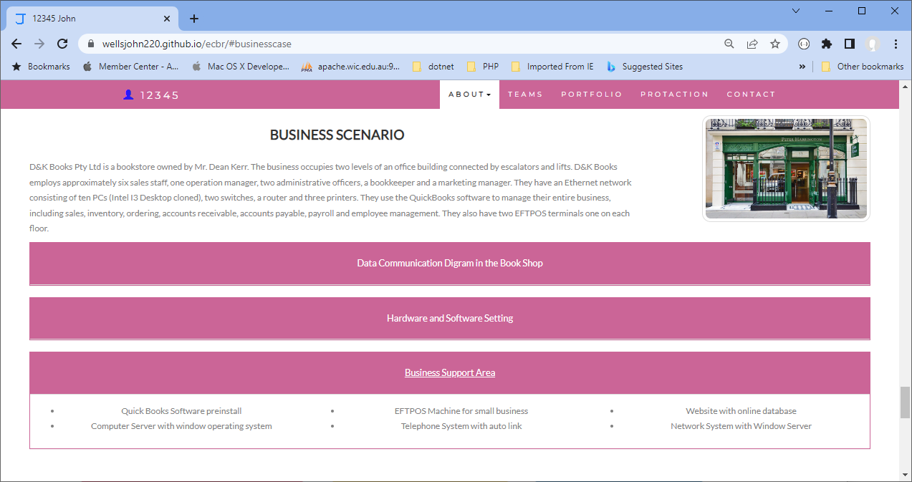

# Task 2: Identify stakeholders

Identify stakeholders related in D&K Books system

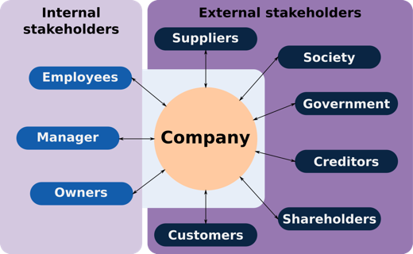All the staffs (the business owner, the relevant manager, the local workers and the remote workers) are internal stakeholders.

Also, clients or customers, investors and shareholders, suppliers, providers, government agencies and the wider community are all external stakeholders.

# Task 3: Develop support procedures

1. Describe one positive and one negative experience you have had when seeking assistance from a telecommunication company, an ISP or a computer supplier. Your experience may be via telephone, email or even voice recognition.

|  |  |  |
| --- | --- | --- |
| Type | Positive | Negative |
| **Telephone** | Easy to get answer | No document, take time to catch someone |
| **Email** | Document, picture, words or any media | Have to wait to get answer |
| **Go to company** | Face to face get answer | Cost time and money on trip, waiting time |
| **Online (AI) chat** | Easy to get answer | Sometime doesn’t get solved & need to call |

1. Using the experiences described above please answer the following questions.
2. What support aspects were professional and/or unprofessional?
3. How long did the support process take?
4. Were the steps logical?
5. Did they solve your problem?
6. Was the call deflected to another area?

I prefer using email or online chat. It sometimes takes time to get response but get documented. I don’t prefer telephone or face to face even if it’s possible to get answer soon there…

|  |  |  |
| --- | --- | --- |
| Items | Professional | Unprofessional |
| 1 | Friendly, Listening, Prompt response, Polite | Not what know your customer |
| 2 | Basically, very quick, sometimes it takes time | Waiting and waiting |
| 3 | Yes | No, annoying sometimes |
| 4 | Yes, and makes me happy | No, and makes me annoyed/ irritate |
| 5 | Sometimes need to be deflected to specialist or responsible for, but solved faster | Deflected to another, another and another,  need to explain each time but doesn’t solve |

Using feedback form or Google survey form.

Here is the very simple survey demo:

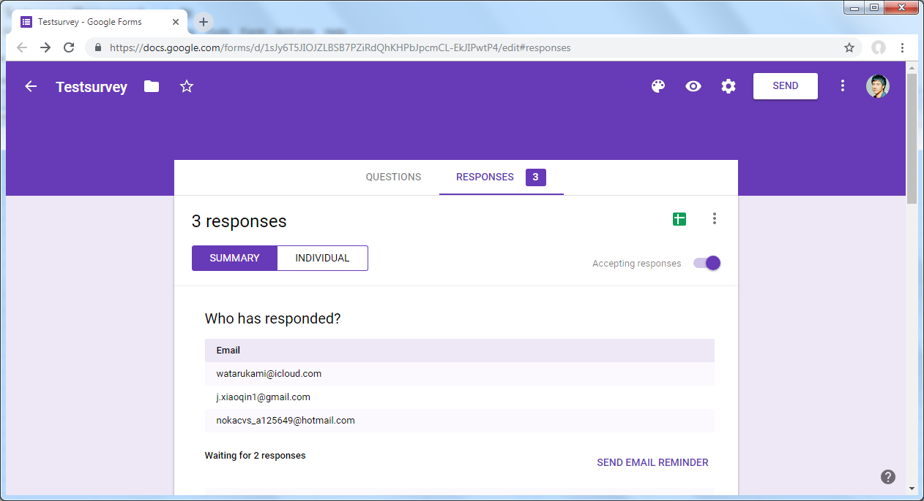

After I tested my friends, I could get nice response like:

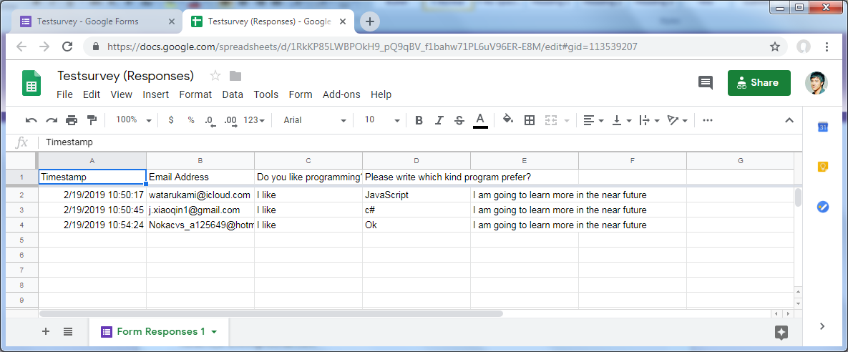

Or using link string:

<https://docs.google.com/spreadsheets/d/1RkKP85LWBPOkH9_pQ9qBV_f1bahw71PL6uV96ER-E8M/edit#gid=113539207>

Please review my website: [https://wellsjohn220.github.io/ecbr/#taskthree](https://wellsjohn220.github.io/ecbr/%23taskthree)

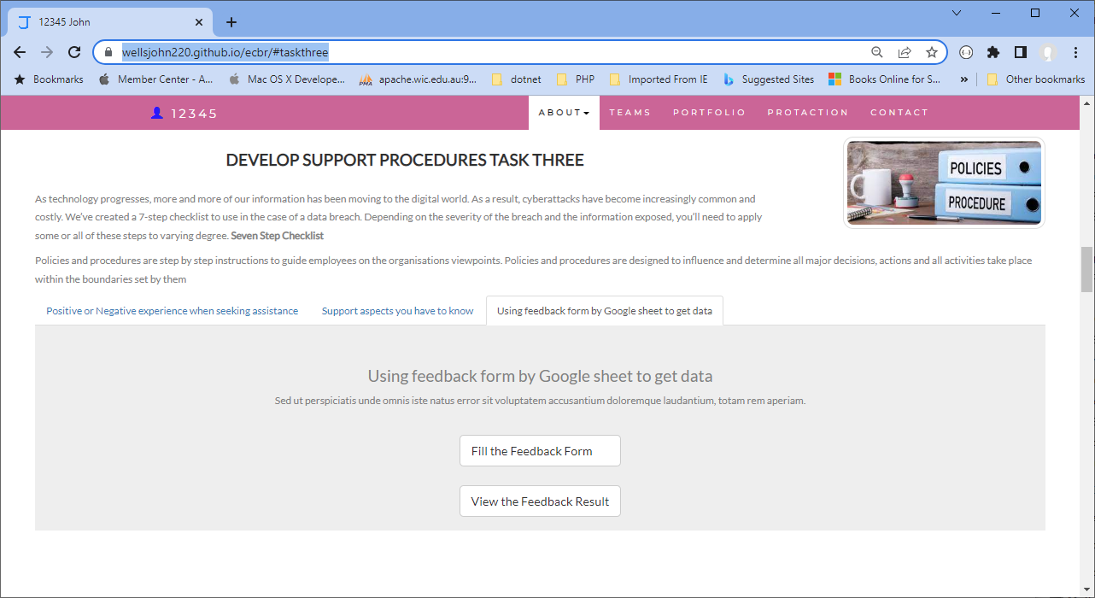

# Task 4: Assign Support Personnel

Classify the following into soft skills and technical skills. Your answer should take the form of a table shown below.

|  |  |  |
| --- | --- | --- |
| **Skill** | **Soft skill** | **Technical skill** |
| A knowledge of Linux |  | ✔ |
| The ability to work under pressure | ✔ |  |
| The administration of Windows 2008 Server |  | ✔ |
| The ability to formulate network and IT policies |  | ✔ |
| The ability to write network documentation |  | ✔ |
| The ability to give presentations | ✔ | ✔ |

Here is about document reequipment at support website: [https://wellsjohn220.github.io/ecbr/#document](https://wellsjohn220.github.io/ecbr/%23document)

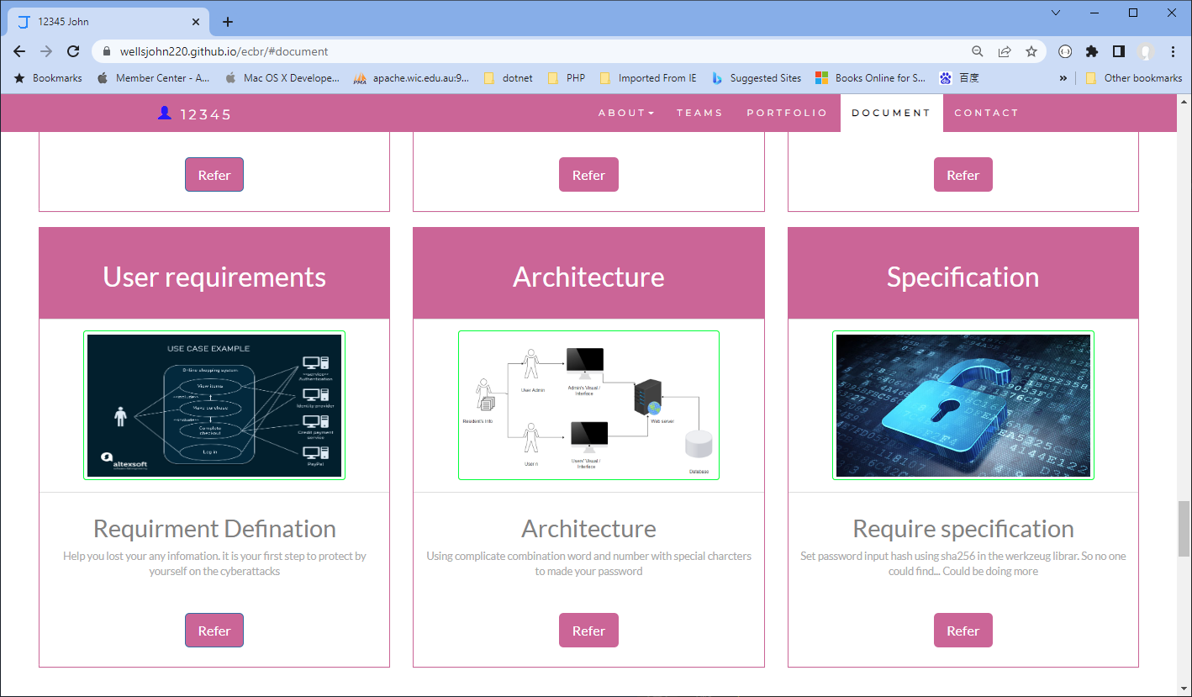

# Task 5: Short Answer Questions

1. 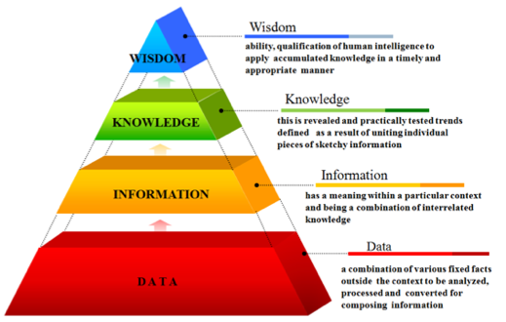Explain the relationship between data, information and knowledge.

**Data** is a collection of facts in a row or unorganized form

**Information** is easier to measure, visualise and analyse data for a specific purpose

**Knowledge** is connected to other pieces help us to understand how to apply information to achieve our goal

And **Wisdom** is knowledge applied in action

Each step up the pyramid from data-information-knowledge-wisdom answers questions about initial data and add values to it. The more we enrich our data with meaning and context, the more knowledge and insights we get out of it. At the top of the pyramid, we have turned the knowledge and insights into a learning experience that guides our actions.

Refer: <https://www.ontotext.com/knowledgehub/fundamentals/dikw-pyramid/>

1. What is quantitative data and how can you use it.

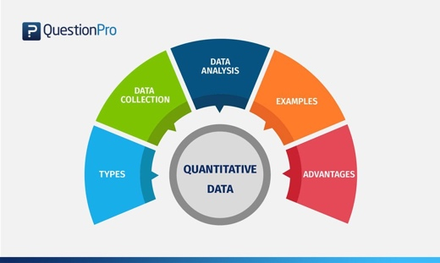**Quantitative data** focuses on numbers, metrics, and the formulation of facts. The numbers you gather from your quantitative research will be the foundation for strong business decisions in the future. Ways to gather quantitative data include conducting A/B testing, closed-question surveys, and web analytics.

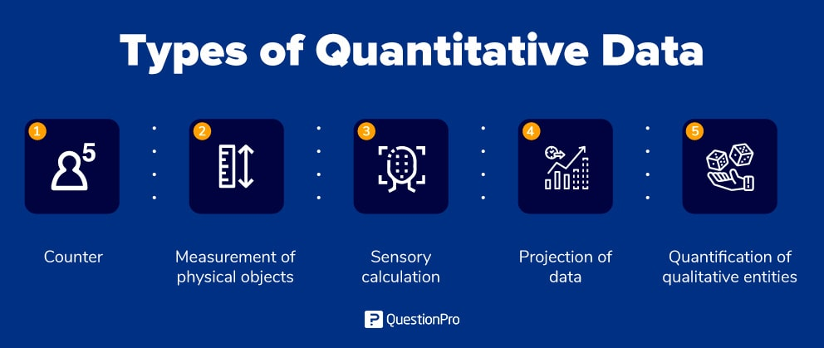

1. What is qualitative data and how can you use it.

**Qualitative data** focuses on the voice of your customers, asking open-ended questions, and developing ideas. Qualitative data reveals customer opinions, values, and beliefs. This data can help you define problems and areas for improvement. Ways to gather qualitative data include conducting focus groups or one-on-one interviews that ask open-ended questions.

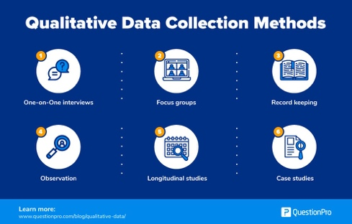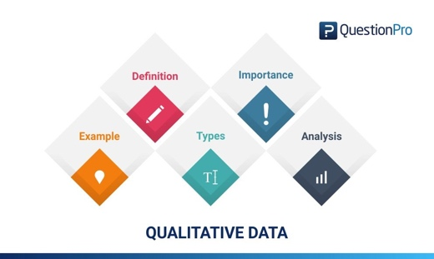

Quantitative data provides you the ***what***, but qualitative data provides you the ***why***

-When you focus only on qualitative results, you risk having a large number of outcomes with too many details or irrelevant conclusions

-When you concentrate solely on quantitative results, you often end up with very broad conclusions without sufficient context

When bringing quantitative and qualitative data together, you’re closing all the gaps.

**A mixed-methods approach** can offer a powerful path towards a deeper understanding of all aspects of your business.

Refer: <https://voccii.com/qualitative-and-quantitative-data#:~:text=Mixed%20Methods%3A%20Two%20Types%20of%20Research&text=Ways%20to%20gather%20quantitative%20data,ended%20questions%2C%20and%20developing%20ideas>.

1. Give an example of how quantitative and qualitative data can be used in conjunction with each other

Example: **Google Analytics + User Interviews**

Google Analytics offers a wealth of quantitative data, such as how many people visited your site, how they got there, and how long they stayed. The information is incredibly helpful and extremely detailed, but without thoughtful interpretation, it’s useless.

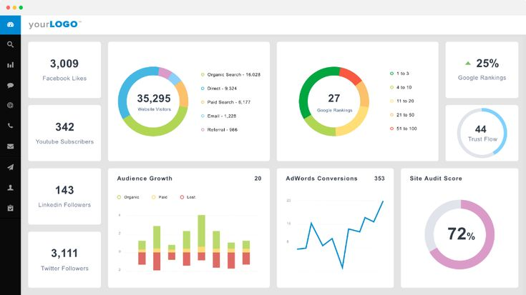In many cases, Google Analytics’ quantitative data will help you pinpoint exactly where your problem lies. But only qualitative data can identify the cause of the issue. Why is that text box causing people to leave your site? Is the field too difficult to fill out? You’ll obtain this information through interviews, co-browsing sessions or feedback tools.

**&**

1. 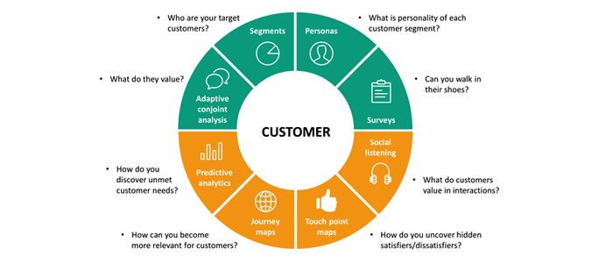What sort of methods could you use to determine client requirements for a website design and key information sources?

* Interview and Questionnaire to understand their requests (Qualitative data)
* Analyse tool such as Google Analytics (Quantitative data)

1. Give some examples of client requirements for a website design

* Graphical user interface

  Description automatically generatedDomain Names, Keywords/SEO, Target Audience, Hosting
* Site Security and Structure
* Audit Existing Content/ Creating New Content
* Existing Site Assets and Functionality/ New Functional Requirements/ Technology Requirements
* Content Management, Project Management
* Deadline and Budget
* Social Media and Marketing

# Chart Description automatically generatedTask 6: Multiple Choice Questions

1. Generally, how many points should a rating scale have?
   1. Five
   2. Four
   3. Ten
   4. Somewhere from 4 to 11 points

Comment: The number of points depends on what sort of question you’re asking, but you should include enough points include a middle or neutral point to allow for differentiation between respondents as much as validly possible without providing so many points that the scale becomes unreliable.

1. 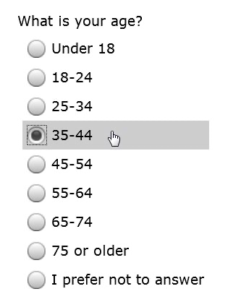What is the problem(s) with this set of response categories to the question “What is your current age?” o 1-5 o 5-10 o 10-20 o 20-30 o 30-40
   1. The categories are not mutually exclusive
   2. The categories are not exhaustive
   3. Both a and b are problems
   4. There is no problem with the above set of response categories

Comment: People aged 5, 10, 20, 30 and over 40 can’t choose one in this question. In this case, the answer should be like; o -19 o 20-29 o 30-39 o 40-49 o 50-59 o 60+

1. You should mix methods in a way that provides complementary strengths and no overlapping weaknesses. This is known as the fundamental principle of mixed research.

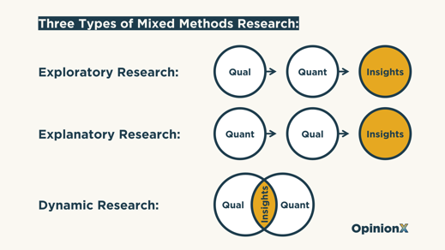a) True

b) False

Comment: Mixed methods research combines elements of quantitative and qualitative research. It can help to gain a more complete picture than a standalone quantitative or qualitative study.

For example:

-How do student perceptions of their school environment (qualitative) relate to differences in test scores (quantitative)?

-How do interviews about job satisfaction at Company X (qualitative) help explain year-over-year sales performance and other KPIs (quantitative)?

Refer: <https://www.scribbr.com/methodology/mixed-methods-research/>

1. According to the text, questionnaires can address events and characteristics taking place when?
   1. In the past (retrospective questions)
   2. In the present (current time questions)
   3. In the future (prospective questions)
   4. All of above

Comment: Questionnaires can address events and characteristics taking place either in the past, present and future. Also, you can ask these types of questions; see the table below.

|  |  |
| --- | --- |
| **Types of Questions** | **Information Sought** |
| **Factual Questions** | Factual information, e.g., Do you have a driver’s license? |
| **Opinion Questions** | Respondent’s personal opinion towards, for instance, soft drinks |
| **Behavioural Questions** | Respondent’s actions or undertaking an activity, e.g., have you travelled overseas this year? |
| **Hypothetical Questions** | Respondent’s answers to hypothetical situations, e.g., what would you do if…. |
| **Demographic Questions** | Respondent’s personal information, such as gender, age, profession, postcode; Used for creating respondent segments |
| **Knowledge Questions** | Used to check respondents’ knowledge about certain issues, e.g., who is the current PM of Australia? |

Refer: <https://westernsydney.pressbooks.pub/customerinsights/chapter/chapter-10-questionnaire-design/>

1. Which of the following are principles of questionnaire construction?
   1. Diagram

      Description automatically generatedConsider using multiple methods when measuring abstract constructs
   2. Use multiple items to measure abstract constructs
   3. Avoid double-barrelled questions
   4. All of the above

Comment: Good questionnaires should be comprehensive, clear, and neutral at least.

Refer: <http://www.analytictech.com/mb313/principl.htm>

1. 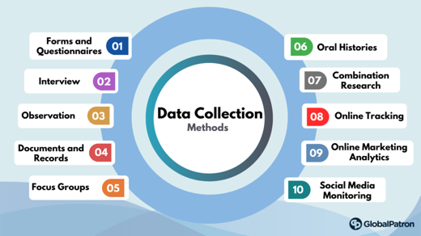Which of these is not a method of data collection?
   1. Questionnaires
   2. Interviews
   3. Experiments
   4. Observations

Comment: Experiment is not a method of data collection, is a procedure which can be repeated for indefinite times. It is also known as trial.

Refer: <https://online.hbs.edu/blog/post/data-collection-methods>

1. Secondary/existing data may include which of the following?
   1. 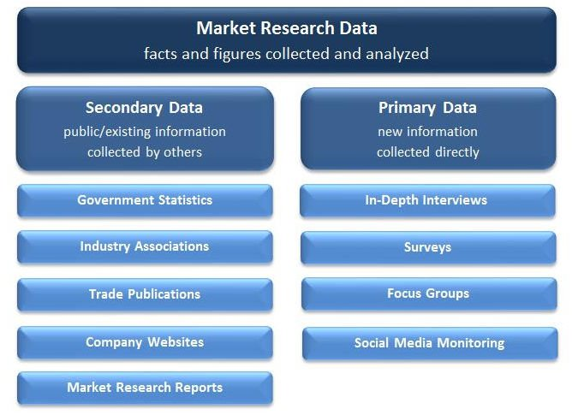Official documents
   2. Personal documents
   3. Archived research data
   4. All of the above

Comment: Primary data refers to the firsthand data gathered by the researcher himself, secondary data means data collected by someone else earlier such as government publications, websites, books, journal articles, internal records etc.

Refer: <https://researchguides.ben.edu/c.php?g=282050&p=4036581#:~:text=Primary%20data%20refers%20to%20the,collected%20by%20someone%20else%20earlier.&text=Surveys%2C%20observations%2C%20experiments%2C%20questionnaire%2C%20personal%20interview%2C%20etc>.

1. 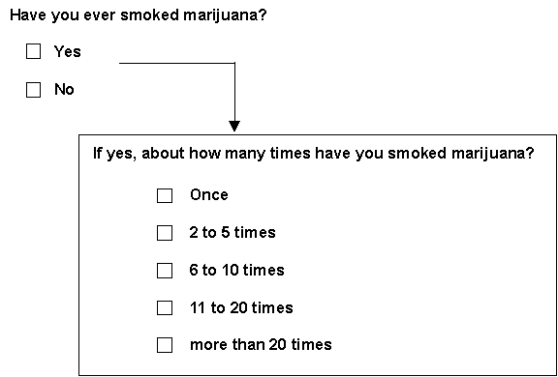An item that directs participants to different follow-up questions depending on their response is called a ____________.
   1. Response set
   2. Probe
   3. Semantic differential
   4. Contingency question

Comment: Contingency questions are questions that are only to be answered by some subgroup(s) of respondents., for example, "If you own your home, how long have you owned it?" Response set is a tendency to respond similarly to all or many questions such as frequently choosing "somewhat agree" on scale options ranging from "strongly agree" to "strongly disagree." Probing questions are intended to help the presenter think more deeply about the issue at hand, for example, "Why do you think this is the case?” "What do you think would happen if…?" Semantic differential scale is a survey or questionnaire rating scale that asks people to rate something or their opinion.

Refer: <https://home.csulb.edu/~msaintg/ppa696/696qstin.htm#:~:text=Contingency%20questions%20are%20questions%20that,or%20open%2Dended%20response%20options>.



1. Which of the following terms best describes data that were originally collected at an earlier time by a different person for a different purpose?
   1. Primary data
   2. Secondary data
   3. Experimental data
   4. Field notes

Comment: Refer the comment of question 7 about primary and secondary data. Experimental data are collected through active intervention by the researcher to produce and measure change or to create difference when a variable is altered. Experimental data typically allows the researcher to determine a causal relationship and is typically projectable to a larger population. Field notes are a qualitative approach most often used in ethnography. Field notes are written observations recorded during or immediately following participant observations in the field and are considered critical to understanding phenomena encountered in the field.

1. 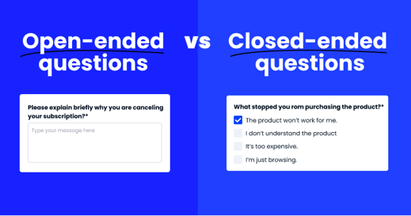Researchers use both open-ended and closed-ended questions to collect data. Which of the following statements is true?
   1. Open-ended questions directly provide quantitative data based on the researcher’s predetermined response categories
   2. Closed-ended questions provide quantitative data in the participant’s own words
   3. Open-ended questions provide qualitative data in the participant’s own words
   4. Closed-ended questions directly provide qualitative data in the participants’ own words

Comment: Open-ended questions are questions that allow someone to give a free-form answer. Closed-ended questions can be answered with “Yes” or “No,” or they have a limited set of possible answers (such as A, B, C, or All of the Above). Quantitative data are measures of values or counts and are expressed as numbers, or numeric variables (such as how many; how much; or how often). Qualitative data are measures of types and may be represented by a name, symbol, or number code.

1. 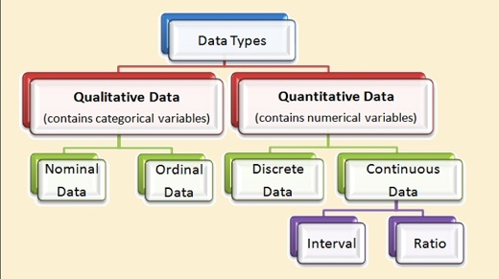Open-ended questions provide primarily ______ data.
   1. Confirmatory data
   2. Qualitative data
   3. Predictive data
   4. None of the above

Comment: Confirmatory data analysis is the part where you evaluate your evidence using traditional statistical tools such as significance, inference, and confidence. Predictive analytics is a form of advanced analytics that uses current and historical data to forecast activity, behaviours and trends.

1. Which of the following is true concerning observation?
   1. It takes less time than self-report approaches
   2. It costs less money than self-report approaches
   3. It is often not possible to determine exactly why the people behave as they do
   4. All of the above

Comment: Self-reporting is when people report on their subjective experiences. Observational data is obtained when information is collected without people directly (by observing).

1. A picture containing diagram

   Description automatically generatedQualitative observation is usually done for exploratory purposes; it is also called ___________ observation.
   1. Structured
   2. Naturalistic
   3. Complete
   4. Probed

Comment: Naturalistic observation is a qualitative research method where you record the behaviours of your research subjects in real world settings. You avoid interfering with or influencing any variables in a naturalistic observation. You can think of naturalistic observation as “people watching” with a purpose.

1. When constructing a questionnaire, it is important to do each of the following except ______.
   1. Use "leading" or "loaded" questions
   2. Use natural language
   3. Understand your research participants
   4. Pilot your test questionnaire

Comment: A leading question prompts someone toward an answer. A loaded question is a trick question. No matter how a respondent answers, they’re saying something that they may not agree with. These questions are written by a survey designer aimed to push the respondent to a specific answer. They create bias and makes the results collected for the question unreliable.

1. Another name for a Likert Scale is a(n):
   1. 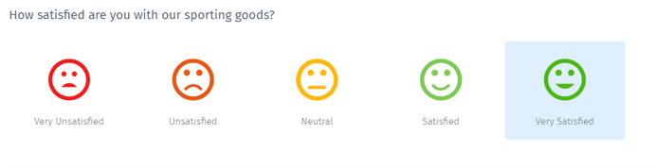Interview protocol
   2. Event sampling
   3. Summated rating scale
   4. Ranking

Comment: Likert scale, rating system, used in questionnaires, that is designed to measure people’s attitudes, opinions, or perceptions.

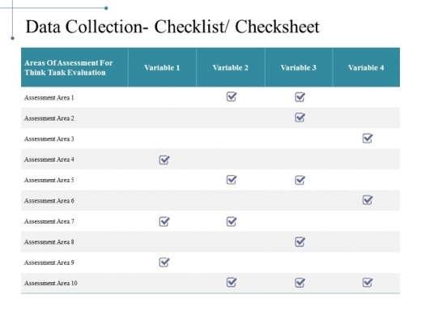

1. Which of the following is not one of the six major methods of data collection that are used by educational researchers?
   1. Observation
   2. Interviews
   3. Questionnaires
   4. Checklists

Comment: The top six data collection methods are: 1) Interviews, 2) Questionnaires and surveys, 3) Observations, 4) Documents and records, 5) Focus groups and 6) Oral histories. Checklists are used to encourage or verify that a number of specific lines of inquiry, steps, or actions are being taken, or have been taken, by a researcher. These surface in a variety of forms throughout data collection and analysis and thereafter as part of either writing or review. Not a method.

1. 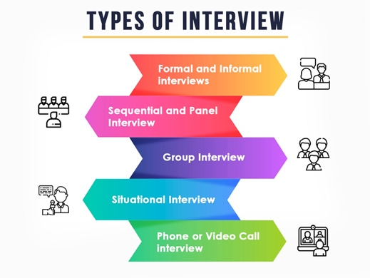The type of interview in which the specific topics are decided in advance, but the sequence and wording can be modified during the interview is called:

a) The interview guide approach

* 1. The informal conversational interview
  2. A closed quantitative interview
  3. The standardized open-ended interview

Comment: An informal interview, also known as a conversational or informal chat interview, is a non-formal job interview, often held in a neutral setting such as a café, usually over food or drink. Closed interview questions limit the respondent's options, and quantitative interviews usually contain closed-ended questions that are delivered in the same format and same order to every respondent. Standardized open-ended interview, the interviewers adhere to a strict script, and there is no flexibility in the wording or order of questions, but the responses are open-ended.

1. Which one of the following in not a major method of data collection?
   1. Questionnaires
   2. Interviews
   3. Secondary data
   4. Focus groups
   5. All of the above are methods of data collection

Comment: Refer the comment on question 16. In addition, Secondary data means data collected by someone else earlier. Surveys, observations, experiments, questionnaire, personal interview, etc. Government publications, websites, books, journal articles, internal records etc.

1. 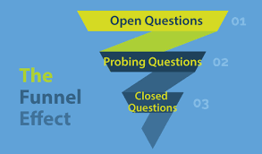A question during an interview such as “Why do you feel that way?” is known as
   1. Probe
   2. Filter question
   3. Response
   4. Pilot

Comment: Probing questions are intended to help the presenter think more deeply about the issue at hand. Filter questions have closed-ended response options that divide the sample into subgroups. They are also called screening questions. For example, "Do you own or rent your home?"

1. A census taker often collects data through which of the following?
   1. Standardized tests
   2. Interviews
   3. Secondary data
   4. Observations

Comment: A census is an official survey of the population of a country that is carried out to find out how many people live there and to obtain details of such things as people's ages and jobs. Census data tells us about the economic, social and cultural make-up of the country.

1. Icon

   Description automatically generatedThe researcher has secretly placed him or herself (as a member) in the group that is being studied. This researcher may be which of the following?

a) A complete participant

* 1. An observer-as-participant
  2. A participant-as-observer
  3. None of the above

Comment: Complete Participant is a fully embedded researcher, almost like a spy. Participants aren't aware that observation and research is being conducted, even though they fully interact with the researcher. An observer-as-participant, the researcher is known and recognized by the participants and in many cases, the participants know the research goals of the observer. A participant-as-observer, the researcher is fully engaged with the participants. While there is full interaction with participants, they still known that this is a researcher.

Refer: <https://measuringu.com/observation-role/>

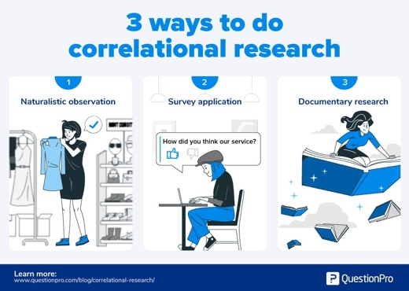

1. Which of the following is not a major method of data collection?
   1. Questionnaires
   2. Focus groups
   3. Correlational method
   4. Secondary data

Comment: Correlational Methods are a form of research that include “quasi-experimental” designs such as survey research or naturalistic observations, in which different groups are compared, but cause and effect between variables cannot be determined.

1. 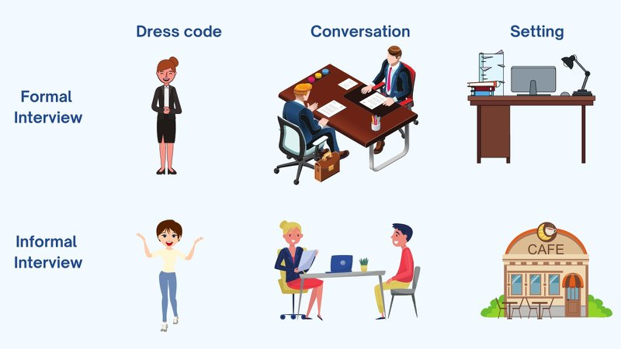Which type of interview allows the questions to emerge from the immediate context or course of things?

a) Interview guide approach

* 1. Informal conversational interview
  2. Closed quantitative interview
  3. Standardized open-ended interview

Comment: Informal Conversational Interview may occur spontaneously in the course of field work, and the respondent may not know that an "interview" is taking place. Questions emerge from the immediate context, so the wording of questions and even the topics are not predetermined.

1. When conducting an interview, asking "Anything else? What do you mean? Why do you feel that way?" etc, are all forms of:
   1. Contingency questions
   2. Probes
   3. Protocols
   4. Response categories

Comment: The protocol is the detailed plan of the study. Every research study should have a protocol, and the protocol should be written. Response categories are dependent on the type of question asked; open questions require a single text field where the respondents can express their opinions without restriction, closed questions have pre-determined responses categories that limit the responses to a set range of values.

1. A hand holding a pen

   Description automatically generated with medium confidenceWhen constructing a questionnaire, there are 15 principles to which you should adhere. Which of the following is not one of those principles?
   1. Do not use "leading" or "loaded" questions
   2. Avoid double-barrelled questions
   3. Avoid double negatives
   4. Avoid using multiple items to measure a single construct

Comment: Using multiple items makes it helpful in analysing the relationship between different variables in the construct and provides more accurate information about the participants.

Here below all the lists of principles of questionnaire construction.

**15 Principles of Questionnaire Construction**

1. Make sure the questionnaire items match your research objectives
2. Understand your research participants
3. Use natural and familiar language
4. Write items that are clear, precise, and relatively short
5. Do not use “leading” or “loaded” questions
6. Avoid double-barreled questions
7. Avoid double negatives
8. Determine whether an open-ended or a closed-ended question is needed
9. Use mutually exclusive and exhaustive response categories for closed-ended questions
10. Consider the different types of response categories available for closed-ended questionnaire items
11. Use multiple items to measure abstract constructs
12. Consider using multiple methods when measuring abstract constructs
13. Use caution if you reverse the wording in some of the items to prevent response sets in multi-item scales
14. Develop a questionnaire that is easy for the participant to use
15. Always pilot test your questionnaire

Refer: <https://www.sagepub.com/sites/default/files/upm-binaries/26101_7.pdf>

1. A customer-based Service Level Agreement structure includes:
   1. Diagram

      Description automatically generated with low confidenceAn SLA covering all customer groups and all the services they use
   2. SLAs for each service that are customer-focused and written in business language
   3. An SLA for each service type, covering all those customer groups that use that service
   4. An SLA with each individual customer group, covering all of the services they use

Comment: A service level agreement SLA is an agreement between an IT Service provider and a customer. A customer-based SLA is a contract with one customer, covering all the services used by this customer. In addition, a service-based SLA covers one service for all customers. Also, a multi-level SLA is a combination of levels with the purpose of addressing multiple sets of customers. The customer contract may define which service level applies. You might use this if you have different tiers of customers who are paying for different types of service plans.

1. Which of the following best describes the goal of Service Level Management?
   1. To maintain and improve IT service quality in line with business requirements
   2. Diagram

      Description automatically generatedTo provide IT services at the lowest possible cost by agreeing with Customers their minimum requirements for service availability and ensuring performance does not exceed these targets
   3. To provide the highest possible level of service to Customers and continuously improve on this through ensuring all services operate at maximum availability
   4. To ensure that IT delivers the same standard of service at the least cost

Comment: The purpose of Service Level Management is to ensure that all current and planned IT services are delivered to agreed achievable targets.

1. The process to implement SLAs comprises of the following activities in sequence:
   1. 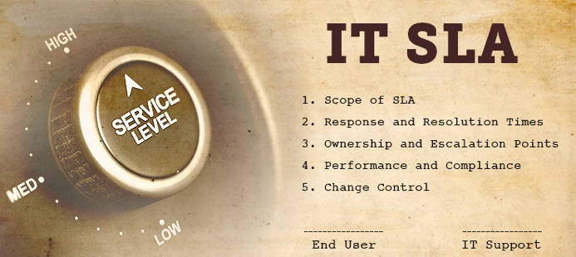Draft SLAs, catalogue services, review underpinning contracts and OLAs, draft SLRs, negotiate, agree SLAs
   2. Draft SLAs, review underpinning contracts and OLAs, negotiate, catalogue services,
   3. Review underpinning contracts and OLAs, draft SLAs, catalogue services, negotiate, agree SLAs
   4. Catalogue services, establish SLRs, review underpinning contracts and OLAs, negotiate service levels, agree SLAs

Comment: The five steps to draw up a great SLA: 1) Define your SLA scope, 2) Set response and resolution times, 3) Create ownership and escalation points, 4) Monitor performance and measure compliance, and 5) Establish change control in the IT SLA.

Refer: <https://blogs.manageengine.com/help-desk/servicedesk/2014/12/10/5-steps-to-successfully-implement-an-it-sla.html>

1. Which of the following is an example of a service level agreement (SLA) between information systems support unit and a research unit in the laboratories of a large company?
   1. Diagram

      Description automatically generatedThe maximum response time to get the system operational should it fail.
   2. The minimum ‘up-time’.
   3. The types of information that will be provided as standard.
   4. All of the above.

Comment: The SLA should include not only a description of the services to be provided and their expected service levels, but also metrics by which the services are measured, the duties and responsibilities of each party, the remedies or penalties for breach, and a protocol for adding and removing metrics.

1. Graphical user interface, website

   Description automatically generatedSome organisations bring a degree of formality to the internal customer concept by encouraging (or requiring) different parts of the operation to agree on:
   1. Internal service agreements
   2. Service level agreements
   3. Formal provision agreements
   4. Delivery agreements

Comment: An internal service level agreement is an agreement between you and an internal customer (such as another organization, site, or department). For example, you are the facilities manager and provide maintenance services for the departments in your company. A contract provision is a stipulation within a contract, legal document, or a law. A formal agreement requires a signed document in addition to verbal consent. If this written contract does not exist, the formal agreement is not legally enforceable. The delivery agreement is an agreement by which a supplier (supplier) undertakes to supply certain goods and/or services, whether or not exclusively, to a customer (customer) and vice versa.

# Search Index

A

A leading question · 18

A loaded question · 18

A mixed-methods approach · 11

a rating scale · 13

B

bookstore · 3

D

Data · 10

data collection · 15, 18, 19, 20

G

Google Analytics · 11, 12

I

Information · 10, 14

K

Knowledge · 10, 14

L

Linux server · 3

N

network · 3

P

Primary data · 15, 16

Q

Qualitative data · 10, 12, 16, 17

Quantitative data · 10, 11, 12, 16

R

response categories · 13, 16, 22

S

Secondary data · 16, 19, 20

Service Level Agreement · 22

Service Level Management · 23

soft skills · 8

support · 6

T

technical skills · 8

technology · 4

telecommunications · 6

W

Wisdom · 10